Assignment -2
1.Display all the details from the employee table
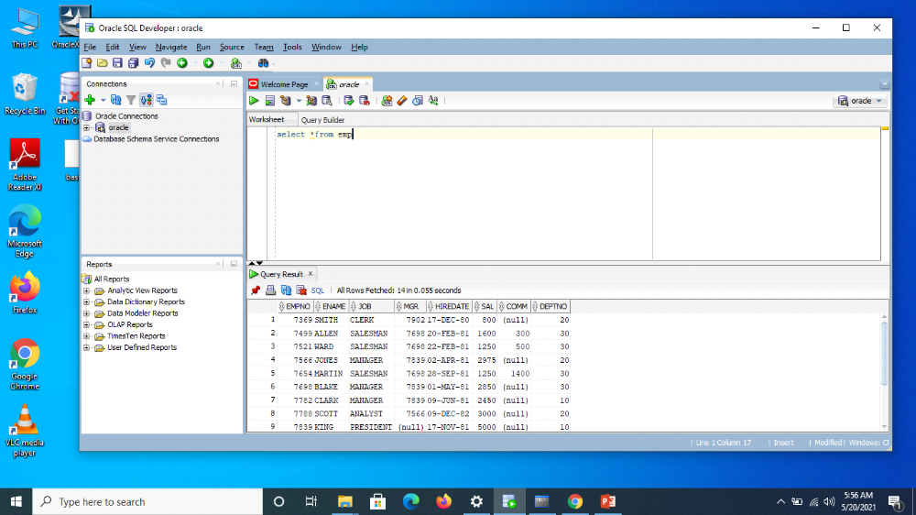
2.List employee details whose salary is greater than 10K.
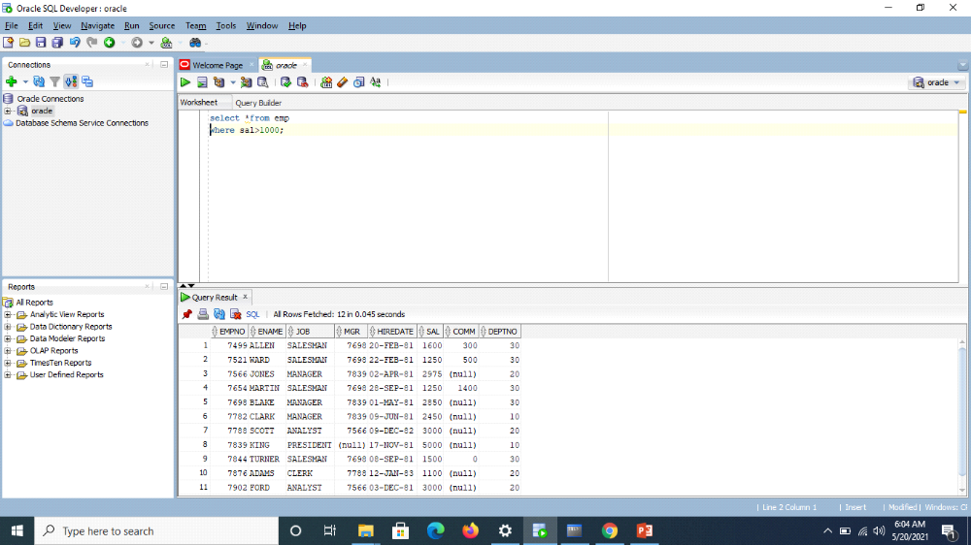
3.List the emps Who Annual sal ranging from 22000 and 45000.
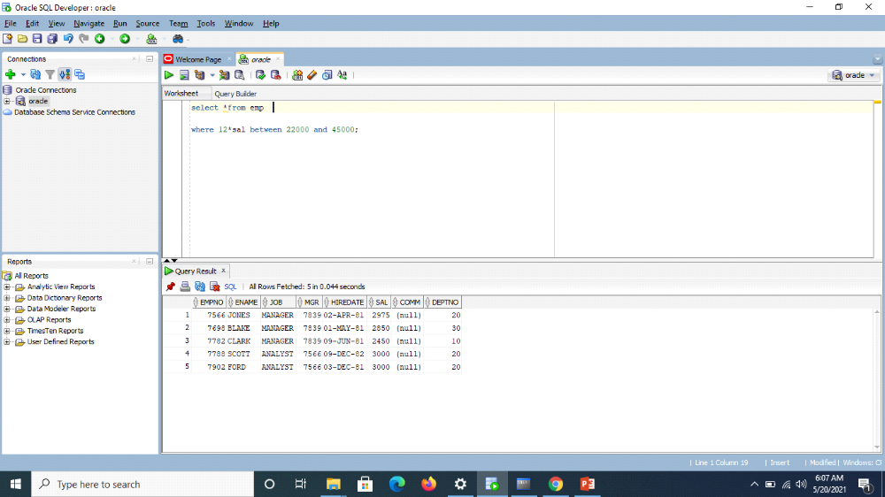
4.List the Five character names starting with ‘S’ and ending with ‘H’.(Doubt)?
5.List the emps who do not belong to Deptno 20.
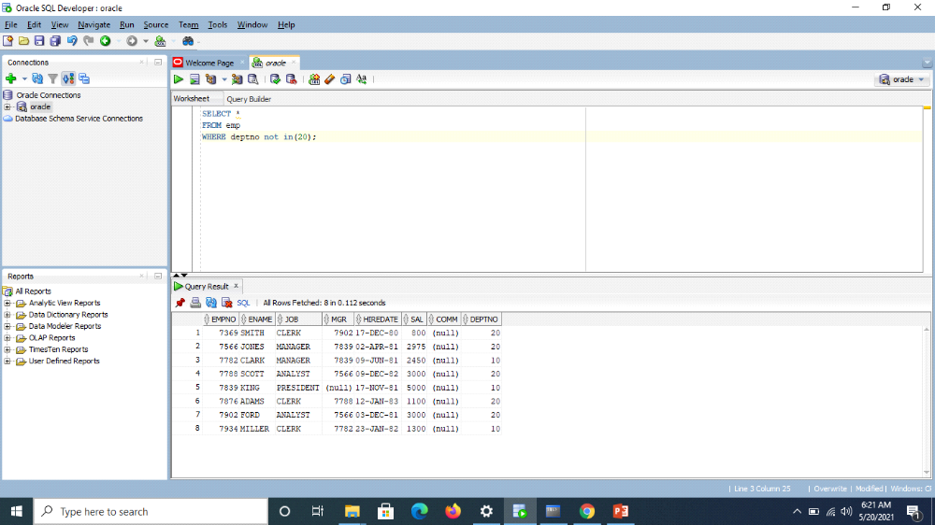
6.Display the location of SMITH.
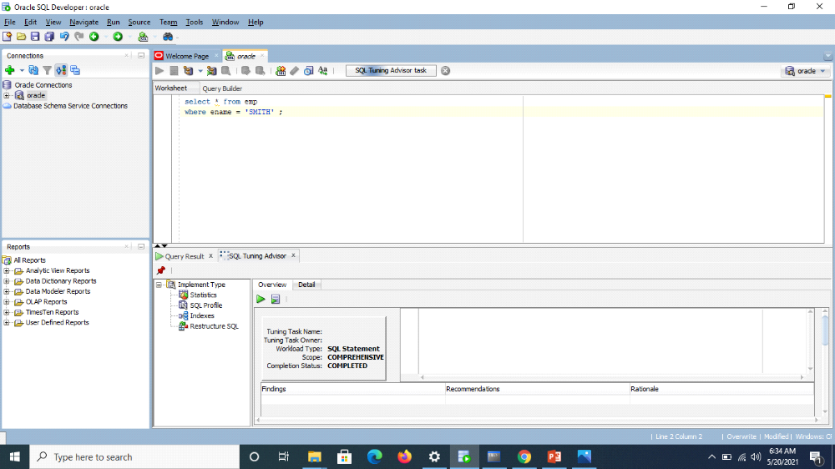
7.Find the total salary given to the MGR.

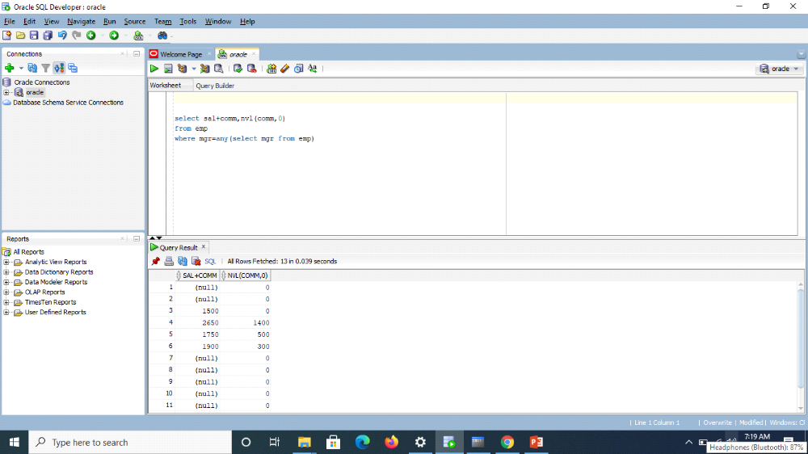
8.List the no. of emps in each department where the no. is more than 3.
9.Display the Grade, Number of emps, and max sal of each grade
10.List the Dname, no of chars of which is = no. of emp’s in any other Dep

